Corey Gaspar
1/17/2026
2-1 Assignment: CRUD in MongoDB
I navigated to the datasets directory in Codio and used the mongoimport utility to load the dataset. I then verified my load by using the city database and running the “db.inspections.find” queries to find an entry based on a specific ID and 10 entries with a result of “Out of Business”, including the names of those businesses.
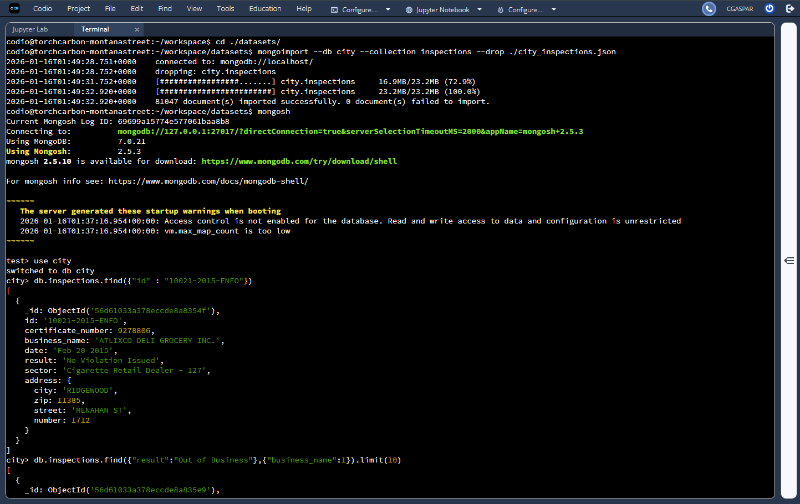

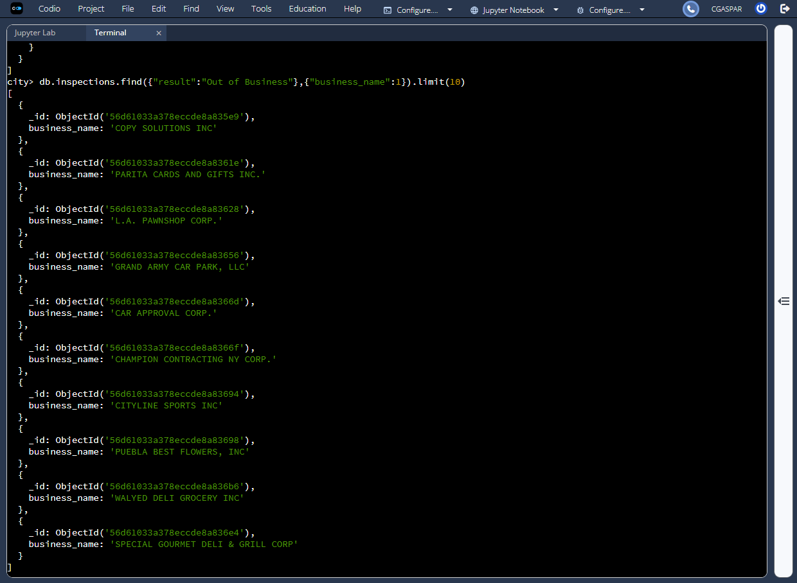
I created a new document using the “db.inspections.insertOne” query, which included all of the necessary information. I then used “findOne” and searched by the ID of the new document.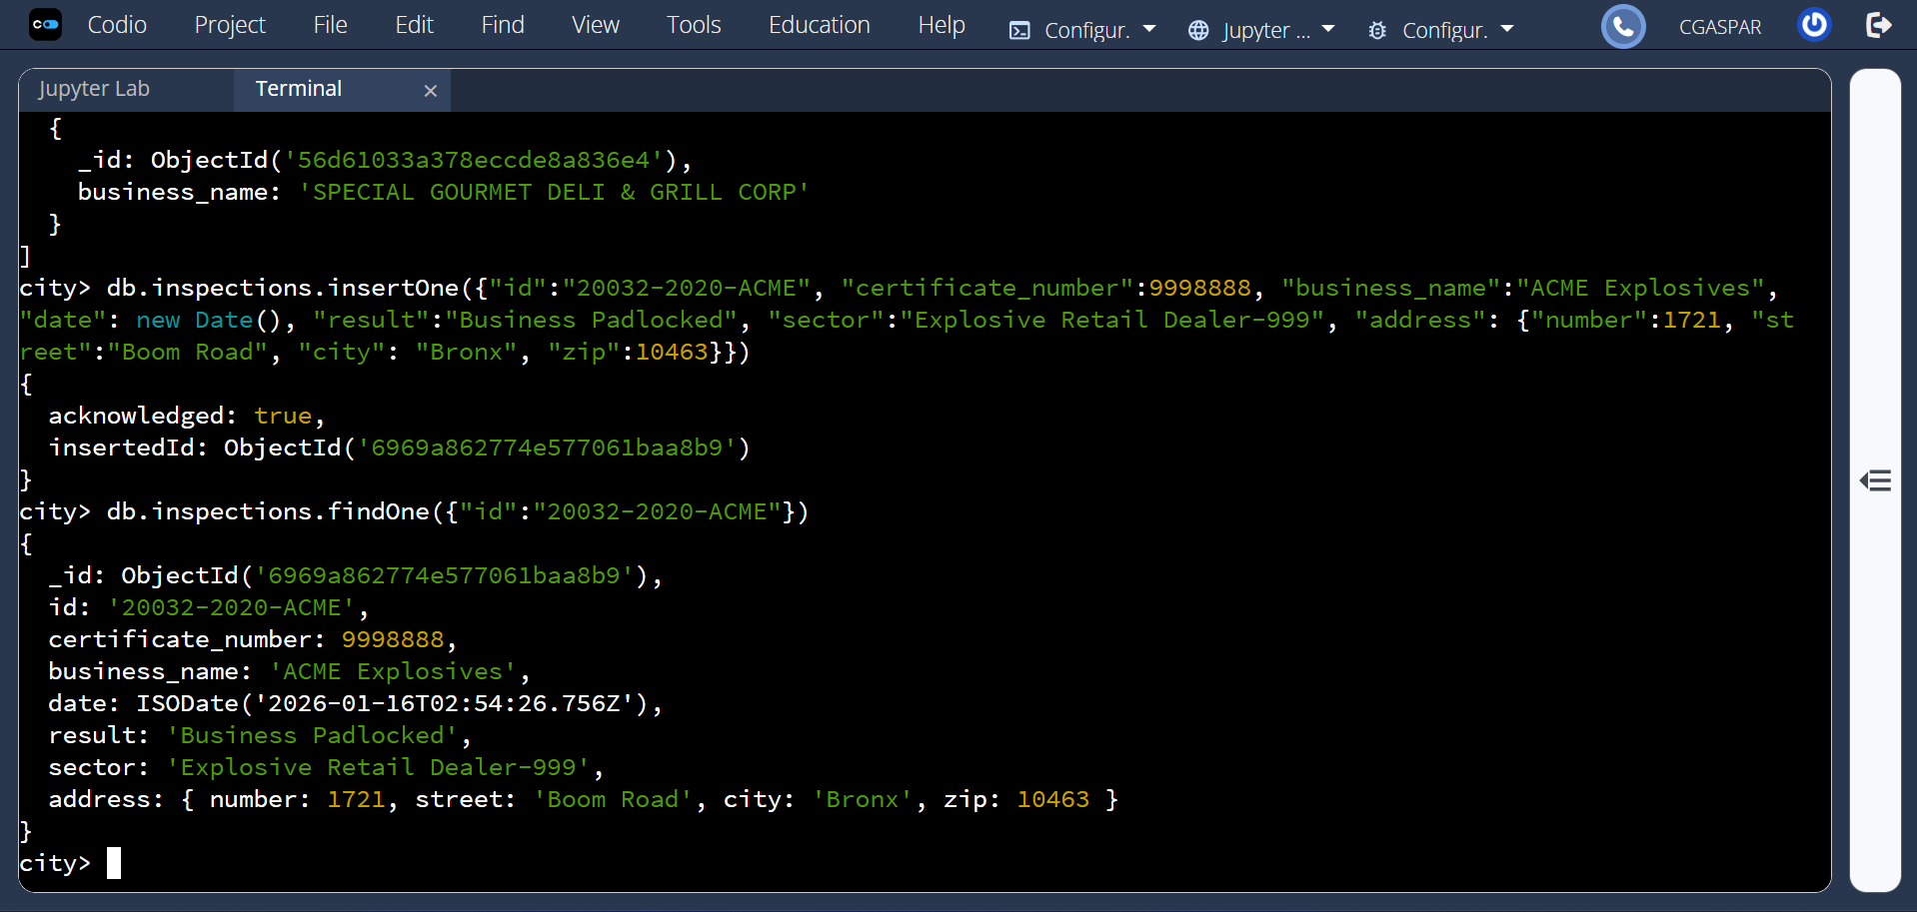
What is the distinct list of inspection “sector” in the current inspections collection? How many are in the list? Do not count by hand.
There are 87 distinct entries in the list.
What is the difference in the date data type for the business named “AUSTIN 2012” versus your business document insertion of “Acme Explosives”?
The date data type for AUSTIN 2012 is a string, while the date data type for ACME Explosives is a data object.
How many businesses have a “Violation Issued”? (See Value column above.)
There is a total of 13,823 businesses that have a violation issued.
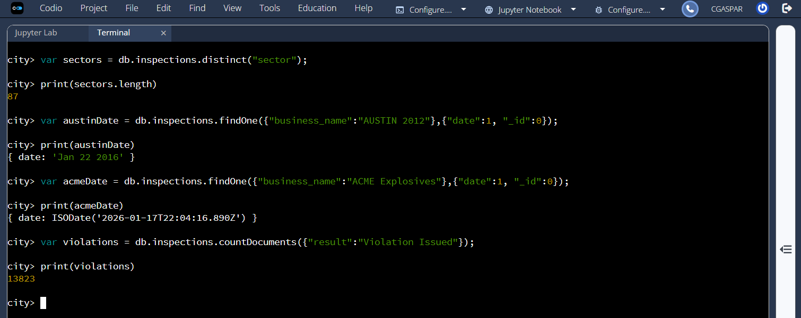

Next, I updated the document with the ID of “20032-2020-ACME” to include the given information.
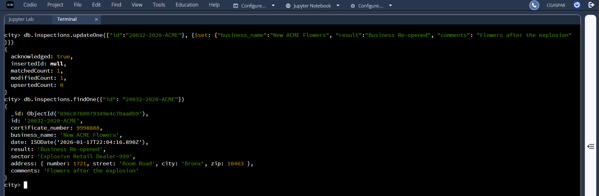
I then updated all documents with the city of Rosedale by changing the zip code to 76114. I removed the first document with a result of Violation Issued.